## Xbeeshield 01.jpg

## Interface Function

[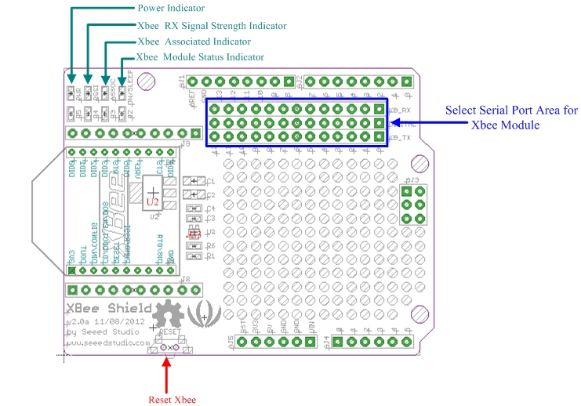](http://www.seeedstudio.com/wiki/File:XBee_Shield_Interface.jpg)

Usage

If you want to control the XBee module by Arduino/Seeeduino, The XBee Shield is required. Here us the RF Bee as a example for wireless communication. You can also use Bluetooth Bee or other modules.

**The steps are listed below:**  
1. Plug XBee Module onto XBee Shield.   
[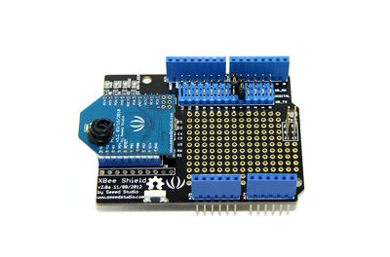](http://www.seeedstudio.com/wiki/File:XBee_Shield_connect_RF_XBee.jpg)[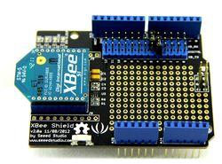](http://www.seeedstudio.com/wiki/File:XBEE1.jpg)  
2. Plug XBee Shield onto Arduino/Seeeduino, connect your Arduino/Seeeduino to the computer via a USB cable to turn it on.  
3. Use a jumper cap to connect XB_TX and Digital 4. Also, Use a jumper cap to connect XB_RX and Digital 5. Of course you can change the digital port as you like. But don't forget to change the port number in the definition of the demo code at the same time.